Question 1 ( 1.0 marks)
What is the value of k for which (27, −7) is a solution of the equation 3x + ky = 25?
A.
8
B.
7
C.
6
D.
5
Solution:
It is given that (27, −7) is a solution of the equation 3x + ky = 25
Therefore, (27, −7) satisfies the given equation.
By substituting x = 27 and y = −7 in 3x + ky = 25, we obtain
3 × 27 + k × (−7) = 25
⇒ 81 − 7k = 25
⇒ −7k = 25 − 81
⇒ −7k = −56
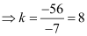
Thus, the required value of k in the given equation is 8.
The correct answer is A.
Question 2 ( 1.0 marks)
What is the distance between the lines x − 10 = 0 and x + 2 = 0?
A.
2 units
B.
8 units
C.
10 units
D.
12 units
Solution:
The line, x − 10 = 0, or x = 10 is parallel to y-axis. It lies at a distance of 10 units from the y-axis in the positive direction of x-axis.
The line, x + 2 = 0, or x = −2 is parallel to y-axis. It lies at a distance of 2 units from the y-axis in the negative direction of x-axis.
These can be shown as
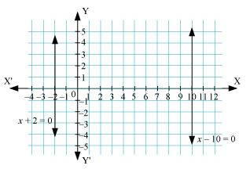
Thus, distance between the lines, x − 10 = 0 and x + 2 = 0 = 2 + 10 units = 12 units
The correct answer is D.
Question 3 ( 1.0 marks)
In a cyclic quadrilateral ABCD, ∠CDB measures 25° and ∠DAC measures 70°. What is the measure of ∠BCD?
A.
75°
B.
85°
C.
95°
D.
105°
Solution:
According to the given information, quadrilateral ABCD can be drawn as:
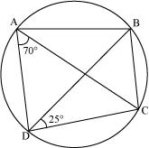
Now, ∠BDC = ∠CAB = 25° (Angles in the same segment are equal)
∴ ∠BAD = ∠BAC + ∠CAD = 25° + 70° = 95°
Now, ∠BAD + ∠BCD = 180°
(Sum of opposite angles in a cyclic quadrilateral is 180°)
∴ ∠BCD = 180° − ∠BAD = 180° − 95° = 85°
The correct answer is B.
Question 4 ( 1.0 marks)
A cylinder and a cone have the same radius and the height of the cone is thrice the height of the cylinder. What is the ratio of the volume of the cylinder to that of cone?
A.
1: 1
B.
1: 2
C.
2: 3
D.
3: 2
Solution:
Let the radius of the cylinder be r.
⇒ Radius of cone = r
Let the height of the cylinder be h.
∴ Height of cone = 3h
Ratio of their volumes = 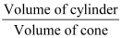
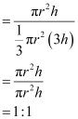
Therefore, the ratio of their volumes is 1: 1.
The correct answer is A.
Question 5 ( 1.0 marks)
Use the following information to answer the next question.
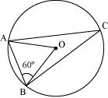
What is the measure of ∠ACB?
A.
15°
B.
20°
C.
30°
D.
35°
Solution:
In ΔAOB, AO = BO
⇒ ∠OAB = ∠OBA (Angles opposite to equal sides are equal)
⇒ ∠OAB = 60°
∴ ∠AOB = 60°
We know that the angle subtended by the arc at the centre is double the angle made by it at any point on the remaining part of the circle.
∴ ∠ACB = 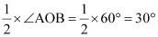
Thus, the measure of ∠ACB is 30°.
The correct answer is C.
Question 6 ( 1.0 marks)
P, Q, R and S are the respective mid-points of the sides AB, BC, CD and AD of quadrilateral ABCD. If AC = 10 cm and BD = 8 cm, then what is the perimeter of quadrilateral PQRS?
A.
16 cm
B.
18 cm
C.
24 cm
D.
36 cm
Solution:
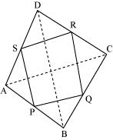
P and Q are the respective mid-points of sides AB and BC of ΔABC.
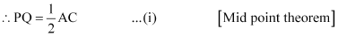
Similarly, 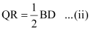
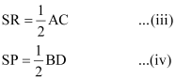
Adding equations (i) to (iv):
PQ + QR + SR + SP = AC + BD = 10 cm + 8 cm = 18 cm
Thus, the perimeter of quadrilateral PQRS is 18 cm.
The correct answer is B.
Question 7 ( 1.0 marks)
Use the following information to answer the next question.
.
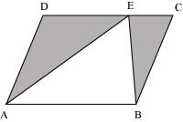
If the area of parallelogram ABCD is 184 cm², then what is the area of the shaded region?
A.
92 cm²
B.
98 cm²
C.
124 cm²
D.
138 cm²
Solution:
It is seen that ΔAEB and parallelogram ABCD lie on the same base AB and between the same parallels AB and CD.
∴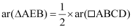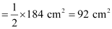
∴Area of shaded region
The correct answer is A.
Question 8 ( 1.0 marks)
If the mean of the data 6, 8, 5, 5, 0, x + 6, x, x + 6, 0, 8 is 2x + 1, then what is the value of x?
A.
2
B.
1
C.
−1
D.
−2
Solution:
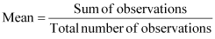
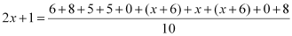
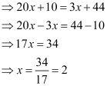
Thus, the value of x is 2.
The correct answer is A.
Question 9 ( 2.0 marks)
Use the following information to answer the next question.
In the given figure, AD is the diameter of the circle with centre O. | 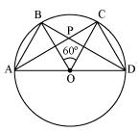
What is the measure of ∠CPD in the given figure?
A.
30°
B.
40°
C.
50°
D.
60°
Solution:
We know that the angle subtended by an arc at the centre of the circle is double the angle subtended by it at any point on the remaining part of the circle.
∴∠BOC = 2 × ∠BDC
⇒ ∠BDC = ∠BOC =× 60° = 30°
We also know that angle in a semi-circle is a right angle.
∴∠ACD = 90°
Applying angle sum property of triangles in ΔPCD, we obtain
∠PCD + ∠CPD + ∠PDC = 180°
⇒ 90° + ∠CPD + 30° = 180°
⇒ 120° + ∠CPD = 180°
⇒∠CPD = 180° − 120° = 60°
Thus, the measure of ∠CPD is 60°.
The correct answer is D.
Question 10 ( 2.0 marks)
Use the following information to answer the next question.
Sixty students were chosen at random from a particular village to know the distance of their school from their respective homes. The information gathered is given in the form of frequency distribution table as:
Distance (in km) | Number of students
0 − 5 | 30
5 − 10 | 11
10 − 15 | 10
15 or more | 9
If a student is chosen at random from the village, then what is the probability that his/her school is 5 km or more farther from his/her house?
A.
B.
C.
D.
Solution:
Total number of chosen students = 60
Number of students whose school is 5 km or more farther from his/her house = 11 + 10 + 9 = 30
Thus, probability that the school of randomly chosen student is 5 km or more farther from his/her house
The correct answer is B.
Question 11 ( 2.0 marks)
If the diameter of a hemispherical bowl is equal to the edge of a cubical vessel, then what is the ratio of the capacities of the hemispherical bowl and the cubical vessel?
A.
11:42
B.
3:8
C.
13:9
D.
14:11
Solution:
Let r be the radius of the hemispherical bowl.
Then, diameter of the hemispherical bowl = 2r
It is given that diameter of hemispherical bowl is equal to the edge of a cubical vessel.
Therefore, edge of the cubical vessel = 2r
Volume of the hemispherical bowl 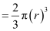
Volume of the cubical vessel = (2r)³ = 8r³
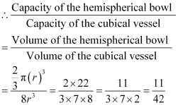
Thus, the ratio of the capacities of the hemispherical bowl and the cubical vessel is 11:42.
The correct answer is A.
Question 12 ( 2.0 marks)
Use the following information to answer the next question.
In the given figure, ABCE is a trapezium and AEDC is a rectangle. | 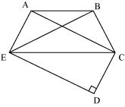
If the area of triangle BEC is 72 cm², then what is the area of quadrilateral BCDE?
A.
92 cm²
B.
144 cm²
C.
122 cm²
D.
130 cm²
Solution:
As ABCE is a trapezium, therefore, AB is parallel to EC.
We know that triangles lying on the same base and between same parallels are equal in area.
Here, ΔAEC and ΔBEC lie on the same base EC and between the same parallels AB and EC.
∴ ar (ΔAEC) = ar (ΔBEC) = 72 cm²
We know that the diagonal of rectangle divides it into two triangles of equal area.
∴ ar (ΔAEC) = ar (ΔECD) = 72 cm²
Now, ar (BEDC) = ar (ΔBEC) + ar (ΔECD)
= 72 cm² + 72 cm²
= 144cm²
The correct answer is B.
Question 13 ( 2.0 marks)
Three times the number of chocolates with Anil is 8 more than five times the number of chocolates that Aarti has. If the number of chocolates that Anil and Aarti have are x and y respectively, then find an equation satisfying the given information.
Solution:
Number of chocolates with Anil = x
Number of chocolates with Aarti = y
Therefore, 8 more than five times the number of chocolates Aarti has = 8 + 5y
It is given that three times the number of chocolates with Anil is 8 more than five times the number of chocolates Aarti has.
∴3x = 8 + 5y
⇒ 3x − 5y − 8 = 0
Thus, the required equation is 3x − 5y − 8 = 0
Question 14 ( 2.0 marks)
The mean of the given data is 3.48. Find the value of m?
x_{i} | f_{i}
1 | 18
2 | 17
3 | m
4 | 6
5 | 16
6 | 21
Solution:
The mean of the given data set is found as follows.
x_{i} | f_{i} | f_{i}x_{i}
1 | 18 | 1 × 18 = 18
2 | 17 | 2 × 17 = 34
3 | m | 3 × m = 3m
4 | 6 | 4 ×6= 24
5 | 16 | 5 × 16 = 80
6 | 21 | 6 × 21 = 126
Total
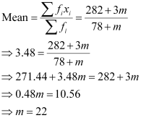
Thus, the value of m is 22.
Question 15 ( 2.0 marks)
Use the following information to answer the next question.
The given table shows the number of T-shirts sold out from a shop for each size of a particular brand during an ongoing festive season.
Size of T-shirt | 36 | 38 | 40 | 42 | 44
Number of T-shirts sold | 54 | 57 | 80 | 39 | 30
What is the probability that the T-shirt which will be sold next is of size 42?
Solution:
Total number of T-shirts sold = 54 + 57 + 80 + 39 + 30 = 260
Number of 42 sized T-shirts sold = 39
Required probability = 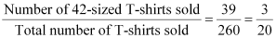
Question 16 ( 2.0 marks)
Use the following information to answer the next question.
A survey is conducted across 1000 families to find out the number of boy child in a family. The given data shows the findings of the survey:
Number of boys in the family | 0 | 1 | 2 | 3
Number of families | 205 | 310 | 435 | 50
What is the probability that a family chosen at random has at most 2 boys?
Solution:
Total number of families = 1000
Number of families having at most 2 boys = 205 + 310 + 435 = 950
Thus, required probability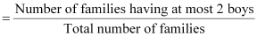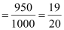
Question 17 ( 2.0 marks)
A conical tent is made up of 251.2 square feet of canvas. If the diameter of the tent is 16 m, then find the height of the tent. [Use π = 3.14]
Solution:
It is evident that the area of the canvas used in making the tent is equal to the lateral surface area of the tent.
It is known that lateral surface area of cone = πrl, where r and l are respectively the radius and the slant height of the cone.
Diameter of the tent= 16 feet
⇒ Radius of the tent, r = 8 feet
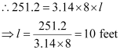
The height (h) of the tent is given by,
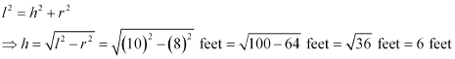
Thus, the height of the tent is 6 feet.
Question 18 ( 2.0 marks)
The given figure represents a rectangle ABCD such that AB = 6 cm and BC = 8 cm. P and Q are the mid-points of the sides AB and BC respectively. Find the length of BR.
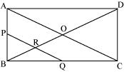
Solution:
Since ABCD is a rectangle, all the interior angles are right angles.
Applying Pythagoras theorem in right-angled ΔABC, we obtain
(AC)² = (AB)² + (BC)²
⇒ (AC)² = 6² + 8² = 100
⇒ AC = 10 cm
In ΔABC, P and Q are the mid-points of the sides AB and BC respectively.
Therefore, by using the mid-point theorem, we obtain
PQ||AC
In ΔABO, PR||AO and P is the mid-point of AB.
Therefore, R is the mid-point of OB. [Converse of mid-point theorem]
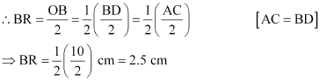
Question 19 ( 2.0 marks)
Use the following information to answer the next question.
In the given figure, ABCD and ABEF are parallelograms. | 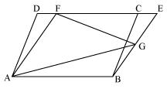
Prove that
(i) area (ABCD) = area (ABEF)
(ii) 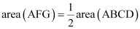
Solution:
(i)
We know that parallelograms on the same base and between the same parallels are equal in area.
Parallelograms ABCD and ABEF are on the same base AB and between the same parallels.
∴ area (ABCD) = area (ABEF) … (1)
(ii)
We know that if a triangle and a parallelogram are on the same base and between the same parallels, then the area of triangle is half the area of parallelogram.
ΔAFG and parallelogram ABEF are on the same base AF and between the same parallels AF and BE.
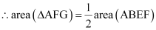
Using result (1), we obtain
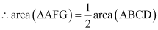
Question 20 ( 3.0 marks)
Use the following information to answer the next question.
In the given figure, ΔABC is equilateral and BC||EG||AD. E is the mid-point of BD. | 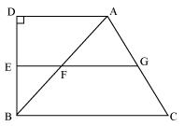
If AD = 5 cm, BD = 12 cm, then find the ratio AD: EG: BC.
Solution:
It is given that EG||AD and E is the mid-point of BD.
Therefore, by the converse of mid-point theorem, F is the mid-point of AB and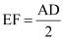
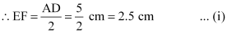
By applying Pythagoras theorem in ΔADB,
AB² = AD² + BD² = (5 cm)² + (12 cm)² = 25 cm² + 144 cm² = 169 cm²
∴AB = 13 cm
Since ΔABC is equilateral, AB = BC = CA = 13 cm
In ΔABC, BC||EG and F is the mid-point of AB.
Therefore, by the converse of mid-point theorem, G is the mid-point of AC and 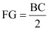
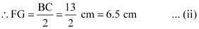
From (i) and (ii), we obtain
EG = EF + FG = 2.5 cm + 6.5 cm = 9 cm
∴AD: EG: BC = 5: 9: 13
Question 21 ( 3.0 marks)
In the given figure, ABCD is a rectangle of dimension 20 cm and 26 cm and ACEF is a parallelogram. Find the area of the parallelogram ACEF.
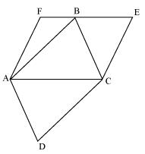
Solution:
The dimensions of the rectangle ABCD are 20 cm and 26 cm.
∴Area of rectangle ABCD = Length × Breadth = 20 cm × 26 cm = 520 cm²
We know that the diagonal of a rectangle divides it into two congruent triangles.
Therefore, ΔABC and ΔADC are congruent.
∴Area (ΔABC) = Area (ΔADC) 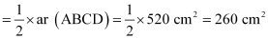
In the given figure, it is seen that ΔABC and parallelogram ACEF lie on the same base AC and between the same parallels AC and EF.
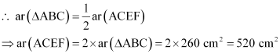
Thus, the area of parallelogram ACEF is 520 cm².
Question 22 ( 3.0 marks)
The given figure shows a circle with centre O. A, B, C, and D are points on the circle such that AB = 16 cm. If CD = 30 cm, then find the distance of the chord CD from the centre.
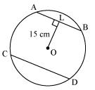
Solution:
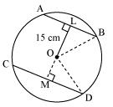
Let M be the foot of the perpendicular drawn from centre O to chord CD.
Join OB and OD
It is known that the perpendicular drawn from the centre of a circle to a chord bisects the chord.
Applying Pythagoras Theorem in right triangle OLB, we obtain
(OB)² = (OL)² + (LB)²
⇒ (OB)² = (15 cm)² + (8 cm)²
⇒ (OB)² = 225 cm² + 64 cm²
⇒ (OB)² = 289 cm²
∴OB = 17 cm
Thus, radius of the circle = 17 cm
∴ OD = 17 cm
Again applying Pythagoras Theorem in right triangle OMD, we obtain
(OD)² = (OM)² + (MD)²
⇒ (17 cm)² = (OM)² + (15 cm)²
⇒ 289 cm² = (OM)² + 225 cm²
⇒ (OM)² = 289 cm² − 225 cm²
⇒ (OM)² = 64 cm²
∴OM = 8 cm
Thus, the distance of chord CD from the centre is 8 cm.
Question 23 ( 3.0 marks)
The floor of a rectangular room has dimensions 5 m × 4 m. The height of the room is 3.5 m. The room has one rectangular door and two rectangular windows. The door has dimensions 200 cm × 80 cm and each window has dimensions 120 cm × 150 cm. Find the cost of painting the inner walls of the room at the rate of Rs 12.50 per m².
Solution:
The length, breadth, and height of the room are given as 5 m, 4 m, and 3.5 m respectively.
Therefore,
Area of the four walls = 2 (Length + Breadth) × Height
= 2 (5 m + 4 m) × 3.5 m
= 2 × 9 m × 3.5 m
= 63 m²
The door and windows are rectangular in shape.
∴Area of the door = Length × Breadth = 200 cm × 80 cm
= 2 m × 0.8 m
= 1.6 m²
Area of each window = Length × Breadth = 120 cm × 150 cm
= 1.2 m × 1.5 m
= 1.8 m²
Therefore, area of the two windows = 2 × 1.8 m² = 3.6 m²
Area which is to be painted
= Area of the four walls − (Area of door + Area of the two windows)
= 63 m² − (1.6 m² + 3.6 m²)
= 63 m² − 5.2 m²
= 57.8 m²
The cost of painting an area of 1 m² is Rs 12.50.
Therefore, cost of painting the inner walls of the room = Rs 12.50 × 57.8
= Rs 722.50
Question 24 ( 3.0 marks)
The lateral surface area and the area of the base of a cone are in the ratio 5:4. If the volume of the cone is 1024 π m³, then find the height of the cone.
Solution:
Let r, l, and h be the radius, slant height, and height of the given cone.
It is given that the lateral surface area and the area of the base of the cone are in the ratio 5:4.
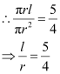
∴l = 5x and r = 4x, where x is some positive real number.
Then,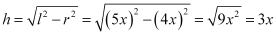
It is also given that the volume of the cone is 1024π m³.
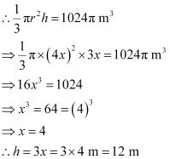
Thus, the height of the cone is 12 m.
Question 25 ( 3.0 marks)
The given figure represents a trapezium ABCD in which AD || BC. P and Q are the mid-points of diagonals BD and AC respectively. Find the perimeter of trapezium ABCD.
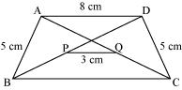
Solution:
Let us join DQ and extend it such that it intersects BC at R.
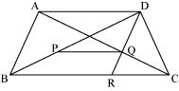
In ΔAQD and ΔCQR,
AQ = CQ (Q is the mid-point of AC)
∠AQD = ∠CQR (Vertically opposite angles)
∠ADQ = ∠CRQ (Alternate interior angles)
∴ ΔAQD ΔCQR (AAS congruency criterion)
⇒ DQ = QR and AD = CR (CPCT)
As DQ = QR, Q is the mid-point of DR.
We have, AD = 8 cm and AD = CR
∴ CR = 8 cm
In ΔDBR, Q is the mid-point of side DR and P is the mid-point of side BD.
∴ 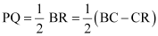
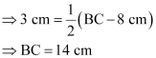
Perimeter of trapezium ABCD = AB + BC + CD + AD = (5 + 14 + 5 + 8) cm = 32 cm
Question 26 ( 3.0 marks)
The given figure represents a trapezium PQRS in which PS||QR. A and B are the mid-points of PS and SR respectively. PBXR is a parallelogram. If area (ΔAPQ) = 24 cm², then find the area of parallelogram PBXR.
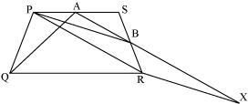
Solution:
Join AR.
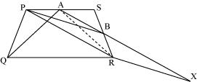
In ΔPSR, A and B are the mid-points of PS and SR respectively.
∴ AB||PR (Mid-point theorem)
ΔAPR and ΔBPR are on the same base PR and between the same parallels, AB and PR.
∴ Area (ΔAPR) = Area (ΔBPR) … (1)
ΔAPR and ΔAPQ are on the same base AP and between the same parallels, AP and QR.
∴ Area (ΔAPR) = Area (ΔAPQ) … (2)
From equations (1) and (2), we obtain
Area (ΔBPR) = Area (ΔAPQ)
⇒ Area (ΔBPR) = 24 cm²
In parallelogram PBXR, BR is a diagonal.
∴ Area of parallelogram PBXR = 2 × Area (ΔBPR)
= 2 × 24 cm²
= 48 cm²
Question 27 ( 3.0 marks)
If the point (−1, 3) is the point of intersection of the lines, 2x + 3y − k = 0 and
kx + py + 1 = 0, then find the value of p.
Solution:
It is given that the point (−1, 3) is the point of intersection of the lines, 2x + 3y − k = 0 and
kx + py + 1 = 0
Therefore, the point (−1, 3) lies on the lines, 2x + 3y − k = 0 and kx + py + 1 = 0
Since the point (−1, 3) lies on the line, 2x + 3y − k = 0, x = −1 and y = 3 satisfies the line, 2x + 3y − k = 0
∴2 (−1) + 3 × 3 − k = 0
⇒ 7 − k = 0
⇒ k = 7
Also, as the point (−1, 3) lies on the line, kx + py + 1 = 0, x = −1 and y = 3 satisfies the line, kx + py + 1 = 0
∴ k (−1) + p(3) + 1 = 0
⇒ 7 (−1) + p × 3 + 1 = 0 [k = 7]
⇒ 3p − 6 = 0
⇒ 3p = 6
⇒ p = 2
Thus, the required value of p is 2.
Question 28 ( 3.0 marks)
Check whether the line passes through the point of intersection of the lines, and.
Solution:
The given lines and can be written as
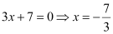and 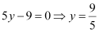
Therefore, is a straight line parallel to the y-axis and is at a distance of units to the left of y-axis.
is a straight line parallel to the x-axis and is units above x-axis.
Thus, it is evident that the given two lines intersect at the point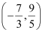.
It can be observed that the point satisfies the line, because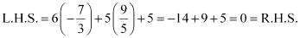
Hence, the line passes through the point of intersection of the given lines.
Question 29 ( 3.0 marks)
114 electrical components were selected at random from a factory as sample. The given frequency table lists the observed lifetimes of the selected electrical components.
Lifetime (in hours) | Number of electrical components
0 − 15 | 16
15 − 30 | 10
30 − 45 | 24
45 − 60 | 31
60 − 75 | 11
75 − 90 | 12
90 − above | 10
What is the probability of an electrical component chosen at random having lifetime more than or equal to 45 hours?
Solution:
Number of electrical components whose lifetime is more than or equal to 45 hours = 31 + 11 + 12 + 10 = 64
Total number of electrical components = 114
Thus, probability of an electrical component chosen at random having lifetime more than 45 hours
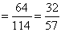
The correct answer is C.
Question 30 ( 4.0 marks)
A cylindrical container can hold a maximum of 3 L 80 mL milk. A new container is made by decreasing the base diameter of the original container by 20% and increasing its height by 25%. Find the maximum amount of milk that the new container can hold.
Solution:
Let d and h be the respective diameter and height of the original container.
∴ Radius of the original container,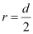
Capacity of the original container = V = πr²h = 3L 80 mL = 3080 mL
The diameter of the original container is decreased by 20%.
∴ Diameter () of the new container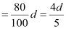
∴ Radius () of the new container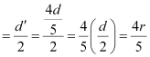
The height of the original container is also increased by 25%.
∴ Height () of the new container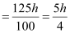
Then, volume of the new container
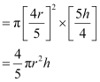
∴ Capacity of the new container is given by,
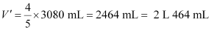
Question 31 ( 4.0 marks)
If 3 is added to the numerator and denominator of a rational number, then the number becomes . Determine the denominator graphically if the numerator is 3.
Solution:
Let the rational number be.
According to the given situation,
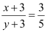
⇒ 5x + 15 = 3y + 9
⇒ 5x − 3y + 6 = 0 … (1)
The two solutions of equation (1) are as follows.
x | 0 | 6
y | 2 | 12
Plotting the points, (0, 2) and (6, 12), we obtain the graph as
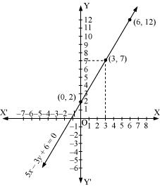
It can be seen from the graph that the value of y, corresponding to x = 3, is 7.
Thus, when the numerator is 3, the denominator is 7.
Question 32 ( 4.0 marks)
The given table shows the salary of 60 workers at a small factory. Draw the frequency polygon of this data.
Salary | Number of workers
3000 − 4000  4000 − 5000  5000 − 6000  6000 − 7000 | 15  25  9  11
Solution:
The histogram of the given data is drawn by taking salary along horizontal axis and number of workers along vertical axis. Then, the bars of each class interval corresponding to its frequency are drawn.
The frequency polygon can be obtained by joining the mid-points of each bar of each class interval of this histogram.
The class-mark of the class interval, 2000 − 3000, (preceding the first class interval) of zero frequency,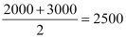
The class-mark of the class interval, 7000 − 8000, (succeeding the last class interval) of zero frequency, 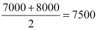
The required polygon can be obtained by joining the mid-points of each bar of the histogram by means of line segments along with the class marks of the two class intervals of zero frequency before the first class interval and after the last class interval.
Thus, the frequency polygon so formed is as follows.
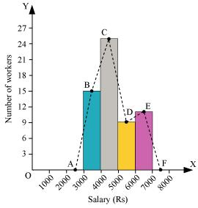
Question 33 ( 4.0 marks)
A, B, C, and D are the respective mid-points of the sides PQ, QR, RS, and SP of a rhombus PQRS where the vertices are taken in order. If the area of quadrilateral ABCD formed is 60 cm², then find the area of rhombus PQRS.
Solution:
Let the diagonals PR and QS of the given rhombus PQRS intersect at point O.
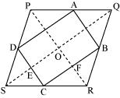
Consider ΔPQR.
Here, A and B are the mid-points of sides PQ and QR respectively. [Given]
Therefore, by the mid-point theorem, we obtain
AB || PR and AB PR … (1)
Similarly in ΔSPR, it is given that C and D are the mid-points of sides RS and SP respectively.
Therefore, again by the mid-point theorem, we obtain
DC || PR and DC PR … (2)
From (1) and (2), we obtain
AB || DC and AB = DC
Therefore, ABCD is a parallelogram.
Similarly, it can also be shown that DA || CB || SQ and DA = CB SQ
OE || FC (as SQ || CB) and OF || EC (as PR || DC)
Therefore, OECF is a parallelogram. … (3)
∴∠ECF = ∠EOF [In parallelogram, opposite angles are equal]
It is also known that in rhombus, diagonals bisect each other at right angles.
∴∠EOF = 90°
⇒ ∠ECF = 90° … (4)
Therefore, from (3) and (4), ABCD is a rectangle.
∴Area of rectangle ABCD = BC × DC
Then, area of rhombus PQRS 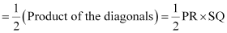
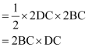
= 2 Area of rectangle ABCD
= 2 × 60 cm²
= 120 cm²
Thus, the area of the rhombus PQRS is 120 cm².
Question 34 ( 4.0 marks)
Construct a ΔABC in which BC = 7 cm, ∠B = 60°, and AB + AC = 12 cm.
Solution:
The required triangle can be constructed as follows.
1. Draw a line segment BC of length 7 cm.
2. Draw a ray BX making an angle of 60° with BC.
3. With B as centre and radius equal to 12 cm, draw an arc which cuts BX at D.
4. Join DC and draw its perpendicular bisector which intersects BD at point A.
5. Join AC. Thus, ΔABC is the required triangle.
