SA II PHYSICS TEST PAPERS I
Question 1 ( 1.0 marks)
Ravinder tries pushing a block by applying a force of 100 N, but the block does not move. How much work is done by him?
Solution:
As the block does not displace, the amount of work done by Ravinder is zero.
Question 2 ( 1.0 marks)
When is the work done on an object negative?
Solution:
When the direction of displacement of an object is opposite to that of the applied force, the work done on the object is said to be negative.
Question 3 ( 1.0 marks)
Name the three bones present in the human ear.
Solution:
The three bones present in the human ear are hammer, anvil and stirrup.
Question 4 ( 1.0 marks)
Which wave characteristic determines the pitch of a sound?
Solution:
The pitch of a sound is determines by frequency.
Question 5 ( 1.0 marks)
Name a unit of work oOther than joule, what unit can be used for expressing work done?.
Solution:
Apart from joule, Nnewton-metre (Nm) can also be used for expressing work done is another unit. of work.
Question 6 ( 1.0 marks)
How is a mechanical wave carried forward in a medium if there is no forward motion of the particles of the medium?
Solution:
A mechanical wave is a disturbance that causes particles of the a medium mediuma to move back and forth about their original position. Their back back-and and-forth movement sets neighbouring particles into similar motion and so on. This is how a wave propagates through the mediummediaum.
Question 7 ( 2.0 marks)
How is ultrasound used for cleaning?
Solution:
The object to be cleaned is placed in a cleansing solution and ultrasound waves are passed through the solution. Due to its high frequency, ultrasound stirs the cleansing solution. As a result of the stirring, the dust particles or grease present on the surface of the object vibrate with a very high frequency, and become loose. These loose particles are easily taken off from the object by the cleansing solution. When the vibration stops, the particles fall into the solution and the solution is then rinsed to remove the dust particles or grease.
Question 8 ( 2.0 marks)
What is the potential energy of a body of mass 4 kg, if it is kept at a height of 5 metres above the ground level? (Take g = 9.8 m/s²)
Solution:
The potential energy of a body is calculated by using the formula
E_{p} = m × g × h
Here,
Mass, m = 4 kg
g = 9.8 m/s²
Height, h = 5 m
∴ E_{p} = 4 × 9.8 × 5
= 20 × 9.8
= 196 J
Question 9 ( 2.0 marks)
Why sound waves are called mechanical waves?
Solution:
A mechanical wave is a disturbance that travels through a media. Since sound requires a medium for propagation, it is classified as a mechanical wave.
Question 10 ( 2.0 marks)
What are the two essential conditions that must be satisfied in order to say that do work is done on a body?
Solution:
The two essential conditions for considering that work to is be done on a body are::—
i. ) A force must act on an object.
ii. ) The object must be have a displaced displacement in a non-perpendicular directionalong the line of action of the applied force.
Question 11 ( 2.0 marks)
Give an example for each of a the following situations. when:—
(i) TThe Object object is not displaced in spite of a force acting on it.
(ii)TThe object gets displaced in the absence of a force acting on it.?.
Solution:
(i) Object is not displaced in spite of a a force acting on it—When someone try tries to push a very large rock but are is unable to displace it.
(ii)Object gets displaced in the absence of a force acting on it—Under ideal conditions, a body moving at constant velocity, experiencing no acceleration is an example.
Question 12 ( 3.0 marks)
Explain the factors on which the speed of sound depends.
Solution:
The factors on which the speed of sound depends are as follows:
(i) Temperature − The speed of sound depends upon the temperature of the medium through which it travels. Its speed increases with the increase in the temperature of the medium.
(ii) Humidity − The speed of sound is directly proportional to the humidity of the medium through which it travels.
(iii) Nature of the medium − The speed of sound depends upon the nature of the medium through which it travels. The speed of sound in a gas is less than its speed in a liquid. Again, the speed of sound in a liquid is less than its speed in a solid.
Question 13 ( 3.0 marks)
Rajat is riding a motorcycle of mass 150 kg. What is the change in kinetic energy when the velocity of the motorcycle increases from 10 m/s to 20 m/s? Rajat’s mass is 80 kg.
Solution:
Combined mass of Rajat and his motorcycle, m = (150 + 80) = 230 kg
Initial velocity, v₁ = 10 m/s
Therefore, the initial kinetic energy is:
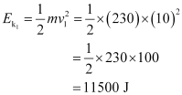
Final velocity of the motorcycle, v₂ = 20 m/s
Therefore, the final kinetic energy is:
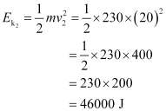
Hence, change in kinetic energy
= 34500 J
Question 14 ( 3.0 marks)
Which of the two objects has a larger capacity of doing work work −— a ball weighing 15 g thrown horizontally at 90 km/hr or a bullet weighing 0.5 g shot horizontally at 500 km/hr?
Solution:
Energy = Capacity of doing work.
Kinetic energy of the ball × Mmass × (Vvelocity)²
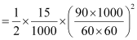
= 4.687 J.
Kinetic energy ofof the bullet × Mmass × (Vvelocity)²
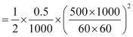
= 4.823 J.
Therefore, the bullet has more capacity of doing work.
Question 15 ( 3.0 marks)
(i) Using pressure-−time graphs, differentiate between the following:
a. Sharp and flat sounds.
b. Soft and loud sounds.
(ii) A sound wave has a frequency of 5 kHz and wavelength of 20 cm. How long will it take to travel 2 km? Will it be audible to a man standing there?
Solution:
(i) a. Flat:-
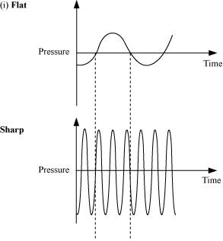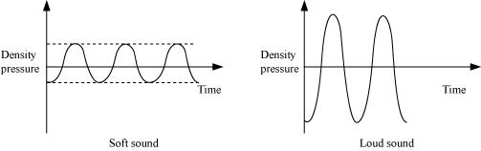
b. Soft:-
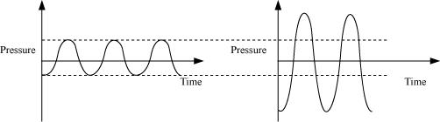
(ii)Given that:,
Ffrequency, ν = 5 KHz kHz = 5,000 Hz
Wwavelength, λ = 20 cm = 0.20 m
Speed (v) of a sound wave is related to its wave length and frequency as: we know that,
speed, v = νλ
= 5,000 × 0.20
= 1,000.0 m/s
Also, 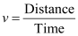
Given that distance = 2 km = 2,000 m
We haveTherefore, time 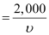
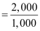
= 2 s.
The sound will take 2 s to travel 2 km.
A man standing there will not be able to hear the wave sound as since its frequency (5,000 Hz) is outside within the range of audible frequencies (20−20,000 Hz) for humans.
SA II PHYSICS PAPERS II
Question 1 ( 1.0 marks)
Which wave characteristic determines the loudness of sound?
Solution:
The loudness of sound is determined by the amplitude of the sound wave.
Question 2 ( 1.0 marks)
What are transverse waves?
Solution:
A transverse wave is one in which the particles of the medium vibrate up and down at right angles to the direction in which the wave is moving.
Question 3 ( 1.0 marks)
What is the SI unit of work?
Solution:
The SI unit of work is newton metre (Nm) or joule (J).
Question 4 ( 1.0 marks)
Define power.
Solution:
The rate of doing work is called power.
Question 5 ( 1.0 marks)
In lifting an object, gravitational force is said to have done negative work. wWhy is it so?
Solution:
The work done in this case is negative because the displacement of the object is directed opposite to the line of action of gravitational force.
Question 6 ( 1.0 marks)
How is human voice produced?
Solution:
Human voice is produced by the vibration of our vocal cords present in the larynx.
Question 7 ( 2.0 marks)
An electric bulb glows when electric current passes through it. Discuss the energy change involved in this process.
Solution:
Electrical energy causes the filament in the bulb to become white-hot. Consequently, the filament gives out light. So, in an electric bulb, electrical energy is first converted into heat energy, and then into light energy.
Question 8 ( 2.0 marks)
Your electricity meter reading of a particular month shows a consumption of 300 units. How much energy is this in joule?
Solution:
1 unit = 1 kWh = 3.6 × 10⁶ J
∴ 300 units = 300 × 3.6 × 10⁶ J
= 1080 × 10⁶ J
= 1.080 × 10⁹ J
Therefore, 300 units meter reading implies 1.080 × 10⁹ J electricity consumption.
Question 9 ( 2.0 marks)
How is ultrasound used for cleaning?
Solution:
The object to be cleaned is placed in a cleansing solution. Due to their high frequency, ultrasound waves are used for stirring the cleansing solution. As a result of the stirring, dust particles and grease vibrate with a very high frequency. Consequently, they become loose, and fall into the solution. The solution is then rinsed to remove the dust particles and grease.
Question 10 ( 2.0 marks)
What are the two conditions for which work done by a non-zero force on an object becomes is zero, by a force that is non-zero?
Solution:
Two conditions for which work done by a non-zero force on an object becomes zero are:—
i). Net Displacement displacement of the object is zero.
ii.) Displacement of the object is perpendicular to the applied force.
Question 11 ( 2.0 marks)
What is the work done by the force of gravity on a satellite moving sound around the earth? Justify your answer.
Solution:
The work done in this case is zero as since the displacement of the a satellite revolving around the earth and the direction of gravitational force is perpendicular.
Question 12 ( 3.0 marks)
cCertain force acting on a 30 30 -kg mass changes its velocity from 5 m/s to 2 m/s. Calculate the work done by the force?.
Solution:
Work done, W = Change in energy.
m (v² − u²)
Where m = Mass
v = Final velocity
u = Initial velocity
Given that:
m = 30 kg
v = 5 m/s
u = 2 m/s
W 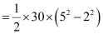
= 15 × (25 − 4)
= 15 × 21
= 315 J
Question 13 ( 3.0 marks)
Mention the medical uses of ultrasound.
Solution:
Medical uses of ultrasound:
(i) It is used for observing the internal parts (which are otherwise difficult to examine) of the human body. This technique is called ultrasonography.
(ii) It is used for monitoring the different stages of development of the foetus inside the womb of a pregnant woman.
(iii) Since ultrasounds are high-frequency or high-energy waves, they can be used for breaking the stones present in gall bladders and kidneys.
Question 14 ( 3.0 marks)
Derive the expression for kinetic energy of a moving object.
Solution:
Suppose an object of mass, m is moving with a uniform velocity, u. Let it be displaced through a distance, s when an external force, F acts upon it. Hence, the work done by the force is F × s. Let the final velocity of the object be v,and the acceleration of the body during the change of velocity be a.
From the third equation of motion, we have
v² − u² = 2as
We can rewrite the equation as
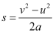
We know that F = ma
∴ Work done, 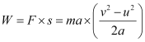
Or, 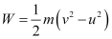
Let us suppose that initially the object was at rest, i.e., u = 0
Then, 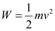
Therefore, the kinetic energy possessed by the object of mass, m, moving with uniform velocity, v is
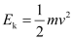
Question 15 ( 5.0 marks)
Two bodies having an equal mass move with uniform velocities v and 3v. Find the ratio of their kinetic energy.
Solution:
It is given that the masses of the two bodies are equal. Let the mass of each body be m.
Mass of the first body = m
Velocity of the first body = v
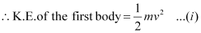
Mass of the second body = m
Velocity of the second body = 3v
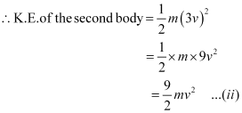
To find the ratio of the kinetic energy of the two bodies, we should divide equation (i) by equation (ii).
Thus, we get
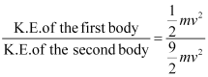
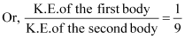
Therefore, the ratio of the kinetic energy of the two bodies is 1 : 9.

